Checking the logs :-

1. Error Log
2. SQL server logs
3. Database Mail Vlog
4. Error Log :- 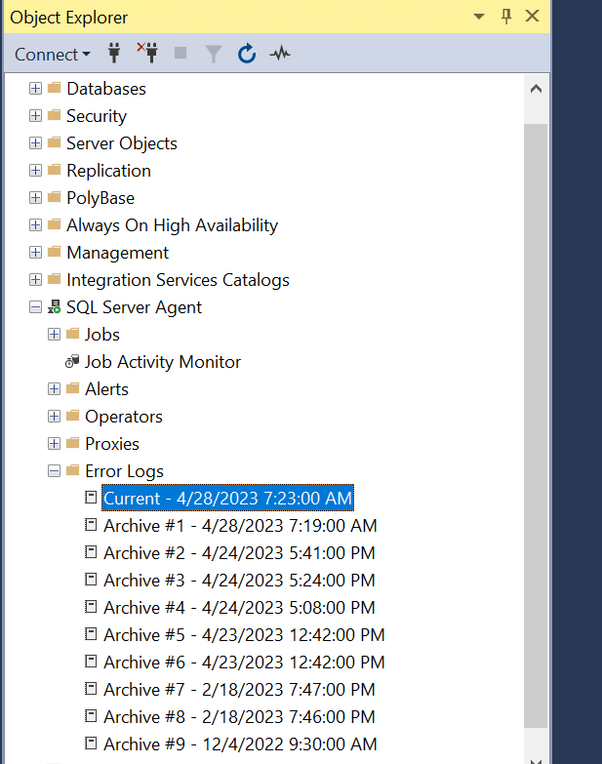
5. SQL server logs

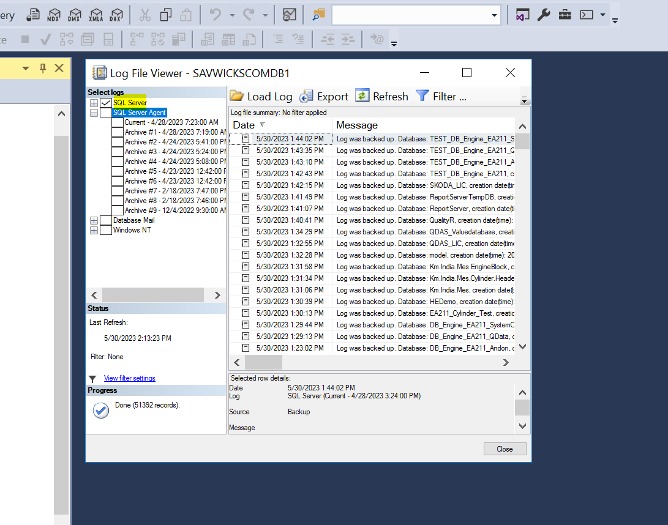

1. Database Mail Vlog:-

